Environmental Services
Ed Potter – Assistant Director: Environmental Services
Bodicote House
Bodicote
Banbury
Oxfordshire
OX15 4AA
www.cherwell.gov.uk
13 September 2021 |  |  | Customer Services |  | 01295 227001

Dear Banbury businesses & residents | 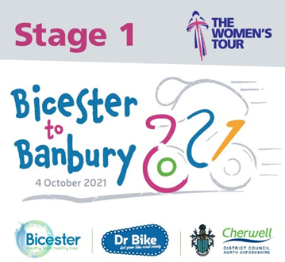
Banbury hosts The Women’s Tour of Britain!

We’re writing to let you know about an exciting sporting event which will be heading past your premises on Monday 4 October.

The Women’s Tour bike race sees the very best international female road cyclists battle it out over six stages to be crowned overall champion and this year, Bicester has the honour of starting the entire Tour whilst the finish of the stage will happen on Banbury’s South Bar.

The beginning of stage one is called The Grand Depart, with the riders, teams, associated media and cycling fans all coming to our District ahead of the 150km route. TV crews will be on hand to film the occasion with Banbury featuring in the highlights show due to be presented on ITV4 that evening.

The route will come into Banbury for the first time along the Broughton Rd, West Bar Street and South Bar Street at approximately 2pm and will then head out of Banbury along the Bloxham Road. The route will do a loop of Cherwell’s Parishes before coming back in along the same route and finishing on South Bar shortly after 3pm.

The full list of predicted timings for the Stage 1 route can be seen here: https://www.womenstour.co.uk/stage-one-timetable/

We are writing to let you know that there will be road and car park closures along with on-street parking restrictions on various streets throughout Monday 4 October.

We appreciate that this could cause some disruption to your day to day operations, and hope that with prior notice of the restrictions that you will be able to work around these timings and hopefully find time to see the race finish on your doorstep.

The main affected restrictions on race day are below (All Monday October 4th unless stated)
South Bar.
Road closed: 4.45am – 6pm.
Parking bays suspended*: From 9pm on Sunday 3rd October – 6pm Monday 4th October.
Broughton Road & West Bar Street.
Access to frontages only: 9am – 6pm.
On street parking/loading/waiting suspended*: 8am – 6pm.
Closed to all traffic at times to allow race to pass: Predicted to be between 2pm – 3pm (See race timings).
Beargarden Road
On street parking/loading/waiting suspended*: 8am – 6pm.
Calthorpe Street
Closed from the A361 to Farmfoods access road*: 4.45am – 6pm.
Calthorpe St West & East Car Parks Closed*. 4am – 6pm.
Dashwood Road
No through road: 4.45am – 6pm.
On street parking/loading/waiting suspended* (South Bar End): 4.45am – 6pm.
One Way enforcement suspended (2 way street): 4am – 6pm.
St Johns Rd
No through road: 4.45am – 6pm.
On street parking/loading/waiting suspended* (South Bar End): 4.45am – 6pm.
High Street
On street parking/loading/waiting suspended from Calthorpe St & Horsefair*: 4.45am – 6pm.
*Due to the nature of the event we will have towing enforcement in place to deal with any vehicles left inside the event or route areas listed above.

A list of alternative car parks available in Banbury are listed below:

Long Stay:
Bolton Road – OX16 5UL
Castle Quay South - OX16 5UN
Compton Road – OX16 2PR
North Bar (West) – OX16 0TH
Riverside – OX16 2AY
Windsor Street – OX16 5AS
NCP Marlborough Road - OX16 5EX
NCP George Street - OX16 5BH
Banbury Train Station East – OX16 4QR
Short Stay:
Chamberlaine Court - OX16 2PA
Horsefair West - OX16 0AN
North Bar (East) - OX16 0TH
The Mill – OX16 5QE
Ultra Short Stay:
Market Place – OX16 5LJ

We apologise in advance for any disruption that this may cause, but we really hope you are able to find time to come and line the route and give the riders a warm Banbury welcome.

For more information about the race, head to www.womenstour.co.uk

Yours faithfully
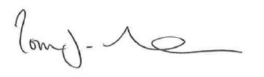
Tom Duckham
Street Scene Manager

